Coffee

Espresso: Espresso is a coffee brewing method that forces hot water through finely-ground coffee beans at high pressure. This results in a concentrated, flavorful shot of coffee with a thick crema.

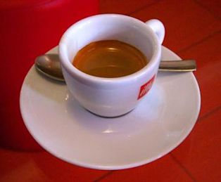

Americano: An Americano is a coffee drink made with espresso and hot water. It is similar to a black coffee, but with a stronger espresso flavor.



Latte: A latte is a coffee drink made with espresso and steamed milk. It is typically served in a tall glass and has a creamy, smooth texture.



Cappuccino: A cappuccino is a coffee drink made with espresso, steamed milk, and foamed milk. It is typically served in a small cup and has a slightly frothy texture.



Mocha: A mocha is a coffee drink made with espresso, chocolate, and steamed milk. It is typically served in a small cup and has a rich, chocolatey flavor.



Tea

Black Tea: Black tea is a type of tea that is fully oxidized, meaning that the leaves have been exposed to the air and have turned brown. Black tea has a strong, full-bodied flavor.



Green Tea: Green tea is a type of tea that is not fully oxidized, meaning that the leaves have been steamed or pan-fired to stop the oxidation process. Green tea has a light, delicate flavor.



Herbal Tea: Herbal tea is a type of tea that is made from dried herbs, flowers, or fruits. Herbal tea does not contain caffeine and has a variety of flavors.



Chai: Chai is a type of tea that is made from black tea, spices, and milk or cream. Chai has a strong, spicy flavor.

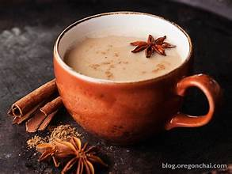

Iced Tea: Iced tea is a type of tea that is brewed hot and then chilled. Iced tea can be made with black tea, green tea, or herbal tea.

